**SAMPLE OPEN API**

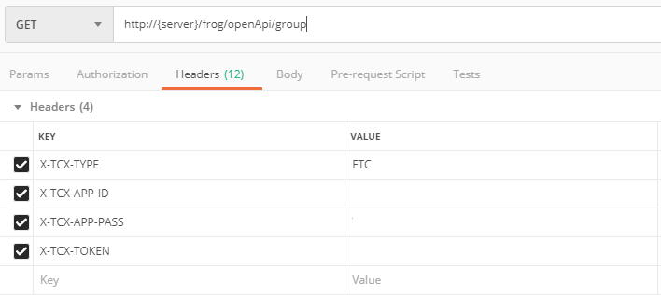***Header :***

1. *Group*
   * *Get*

*Response*

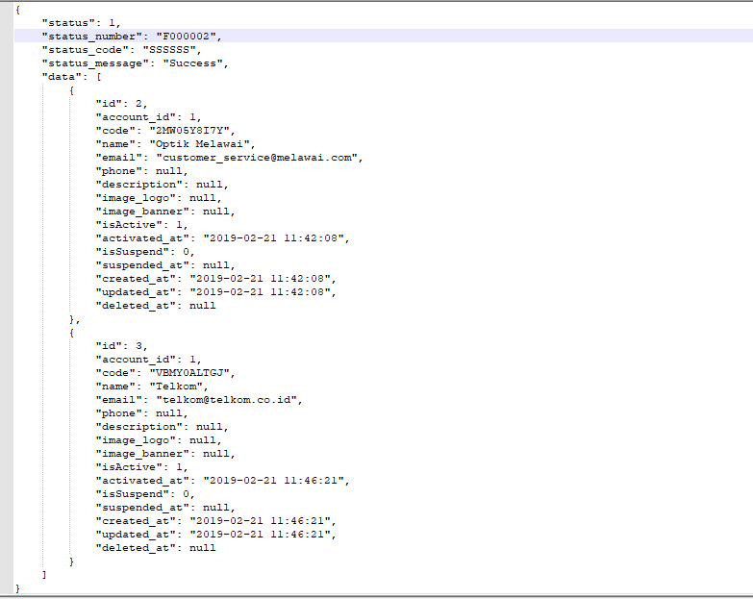

* + *Add*

*Parameters :*

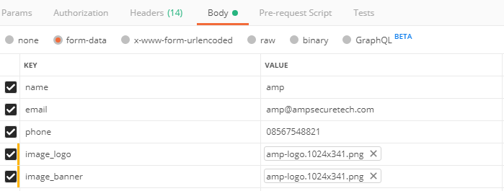

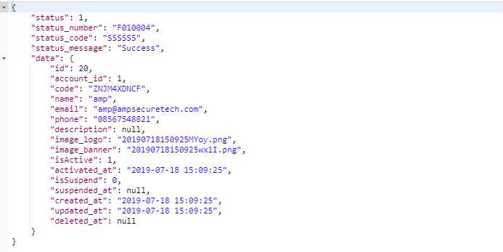*Response:*

* + *Update*

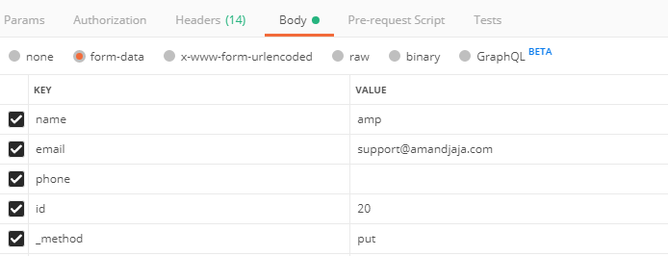*Parameters :*

*Response :*

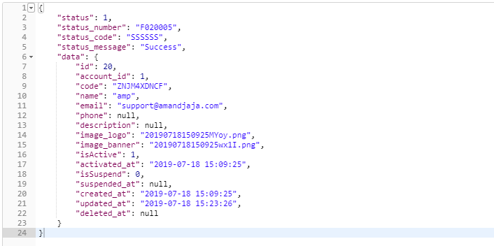

* + *Delete*

*Parameters :*

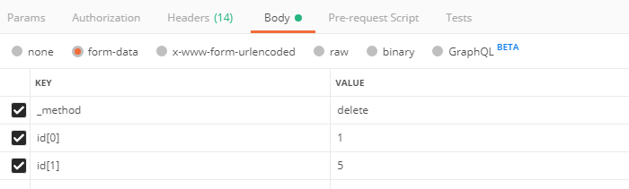

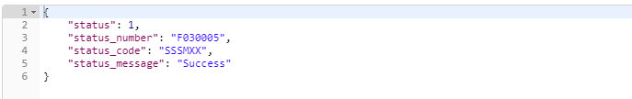*Response :*

1. *Advertisement*
   * *Get*

*Response :*

{

"status": 1,

"status_number": "F000001",

"status_code": "SSSSSS",

"status_message": "Success",

"data": [

{

"id": 48,

"account_id": 1,

"group_id": 19,

"name": "EF Back to School",

"code": "20190711152039OUZL6E",

"description": null,

"priority": 1,

"_start": "2019-07-12",

"_end": "2019-08-13",

"type": "01",

"gender": null,

"_impression": 183555,

"_click": 618,

"_view": 0,

"_action": 0,

"_lead": 0,

"_unlead": 0,

"budget": 1000000,

"price": 1,

"isDaily": 0,

"daily_target": null,

"daily_reach": 0,

"target": 1000000,

"hit": 185,

"reach": 185,

"isFeatured": 0,

"isSelected": 0,

"isSelectedPlace": 1,

"os": [],

"isActive": 1,

"status": "00",

"created_at": "2019-07-11 15:20:39",

"updated_at": "2019-07-17 10:07:34",

"deleted_at": null,

"placement_ids": [

1

],

"age_ranges": [],

"kotas": [],

"witels": [],

"regionals": [],

"type_text": "cpm",

"gender_text": "",

"status_text": "process",

"account": {

"id": 1,

"tcx_application_id": 1,

"tcx_app_id": null,

"tcx_public_key": null,

"tcx_secret_key": null,

"tcx_auth_type": null,

"tcx_master_key": null,

"username": "ampgroup",

"email": "support@amandjaja.com",

"isEmailValid": 1,

"phone": null,

"isPhoneValid": 0,

"firstname": "AMP",

"lastname": null,

"gender": "00",

"birthdate": null,

"birthplace": null,

"address": null,

"address_second": null,

"isActive": 1,

"activated_at": "2019-02-21 09:14:08",

"isSuspend": 0,

"suspended_at": null,

"balance": 0,

"balance_key": "eyJpdiI6Ikdza3ZsYXlucHE2WDFxUFhUemlzd0E9PSIsInZhbHVlIjoiZnFLc0R2R0xYckN6eDhDZllHQUJRZz09IiwibWFjIjoiM2U4ODAxZTdjOGVlODlhMTM5NGJiYjkzZmMyMmQyMGIwYjQ0YTkwMGU4OTI3OTUxZThiMGY1ZWY4YjY4OTE0ZCJ9",

"balance_expired_at": null,

"balance_hold": 0,

"balance_hold_key": "eyJpdiI6Im5RWlwvcUlCVHFuNlNBWHBNbmpKdkVRPT0iLCJ2YWx1ZSI6IkZIRGxDS3Q2MyszZXlEdjR1UGpRZHc9PSIsIm1hYyI6IjEzMzZhMThmNWVkNzQ1OTFhNGI0OWUyYzIzZWVkMzc4MzI1MGYyY2U3NzIzMjdhMzAyZjgwYjJjMjhhNWY2NzkifQ==",

"ip": null,

"last_ip": null,

"login_at": null,

"last_login_at": null,

"created_at": "2019-02-19 15:19:36",

"updated_at": "2019-02-21 09:14:08",

"deleted_at": null,

"session_ids": [],

"gender_text": "male",

"telkom_ap_id": []

},

"group": {

"id": 19,

"account_id": 1,

"code": "TAAPUL2IJB",

"name": "English First",

"email": "ef@gmail.com",

"phone": null,

"description": null,

"image_logo": null,

"image_banner": null,

"isActive": 1,

"activated_at": "2019-07-11 15:18:44",

"isSuspend": 0,

"suspended_at": null,

"created_at": "2019-07-11 15:18:44",

"updated_at": "2019-07-11 15:18:44",

"deleted_at": null

},

"hours": [

{

"advertisement_id": 48,

"_day": 0,

"_start": 0,

"_end": 23

},

{

"advertisement_id": 48,

"_day": 1,

"_start": 0,

"_end": 23

},

{

"advertisement_id": 48,

"_day": 2,

"_start": 0,

"_end": 23

},

{

"advertisement_id": 48,

"_day": 3,

"_start": 0,

"_end": 23

},

{

"advertisement_id": 48,

"_day": 4,

"_start": 0,

"_end": 23

},

{

"advertisement_id": 48,

"_day": 5,

"_start": 0,

"_end": 23

},

{

"advertisement_id": 48,

"_day": 6,

"_start": 0,

"_end": 23

}

],

"placements": [

{

"id": 1,

"account_id": 1,

"name": "GLOBAL Wifi.ID",

"code": "GLOBALWIFIID",

"description": null,

"isActive": 1,

"created_at": "2019-04-11 09:59:34",

"updated_at": null,

"deleted_at": null,

"pivot": {

"advertisement_id": 48,

"placement_id": 1

}

}

],

"aps": []

}

]

}

* + *Add*

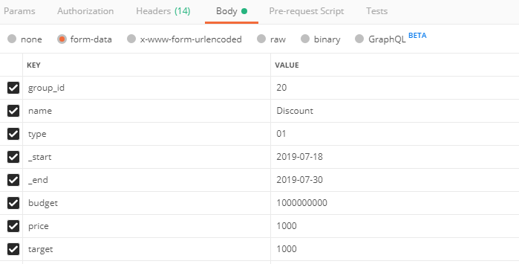*Parameters :*

*Response :*

{

"status": 1,

"status_number": "F010005",

"status_code": "SSSSSS",

"status_message": "Success",

"data": {

"id": 49,

"account_id": 1,

"group_id": 20,

"name": "Discount",

"code": "20190718160931FY1SYD",

"description": null,

"priority": 1,

"_start": "2019-07-18",

"_end": "2019-07-30",

"type": "01",

"gender": null,

"_impression": 0,

"_click": 0,

"_view": 0,

"_action": 0,

"_lead": 0,

"_unlead": 0,

"budget": 1000000000,

"price": 1000,

"isDaily": 0,

"daily_target": null,

"daily_reach": 0,

"target": 1000,

"hit": 0,

"reach": 0,

"isFeatured": 0,

"isSelected": 0,

"isSelectedPlace": 1,

"os": [],

"isActive": 0,

"status": "00",

"created_at": "2019-07-18 16:09:31",

"updated_at": "2019-07-18 16:09:31",

"deleted_at": null,

"placement_ids": [],

"age_ranges": [],

"kotas": [],

"witels": [],

"regionals": [],

"type_text": "cpm",

"gender_text": "",

"status_text": "process",

"account": {

"id": 1,

"tcx_application_id": 1,

"tcx_app_id": null,

"tcx_public_key": null,

"tcx_secret_key": null,

"tcx_auth_type": null,

"tcx_master_key": null,

"username": "ampgroup",

"email": "support@amandjaja.com",

"isEmailValid": 1,

"phone": null,

"isPhoneValid": 0,

"firstname": "AMP",

"lastname": null,

"gender": "00",

"birthdate": null,

"birthplace": null,

"address": null,

"address_second": null,

"isActive": 1,

"activated_at": "2019-02-21 09:14:08",

"isSuspend": 0,

"suspended_at": null,

"balance": 0,

"balance_key": "eyJpdiI6Ikdza3ZsYXlucHE2WDFxUFhUemlzd0E9PSIsInZhbHVlIjoiZnFLc0R2R0xYckN6eDhDZllHQUJRZz09IiwibWFjIjoiM2U4ODAxZTdjOGVlODlhMTM5NGJiYjkzZmMyMmQyMGIwYjQ0YTkwMGU4OTI3OTUxZThiMGY1ZWY4YjY4OTE0ZCJ9",

"balance_expired_at": null,

"balance_hold": 0,

"balance_hold_key": "eyJpdiI6Im5RWlwvcUlCVHFuNlNBWHBNbmpKdkVRPT0iLCJ2YWx1ZSI6IkZIRGxDS3Q2MyszZXlEdjR1UGpRZHc9PSIsIm1hYyI6IjEzMzZhMThmNWVkNzQ1OTFhNGI0OWUyYzIzZWVkMzc4MzI1MGYyY2U3NzIzMjdhMzAyZjgwYjJjMjhhNWY2NzkifQ==",

"ip": null,

"last_ip": null,

"login_at": null,

"last_login_at": null,

"created_at": "2019-02-19 15:19:36",

"updated_at": "2019-02-21 09:14:08",

"deleted_at": null,

"session_ids": [],

"gender_text": "male",

"telkom_ap_id": []

},

"group": {

"id": 20,

"account_id": 1,

"code": "ZNJM4XDNCF",

"name": "amp",

"email": "support@amandjaja.com",

"phone": null,

"description": null,

"image_logo": "20190718150925MYoy.png",

"image_banner": "20190718150925wx1I.png",

"isActive": 1,

"activated_at": "2019-07-18 15:09:25",

"isSuspend": 0,

"suspended_at": null,

"created_at": "2019-07-18 15:09:25",

"updated_at": "2019-07-18 15:23:26",

"deleted_at": null

},

"hours": [],

"placements": [],

"aps": []

}

}

* + *Update*

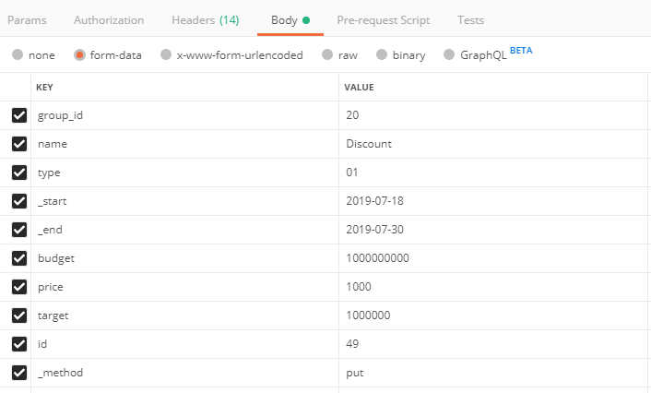*Parameters :*

*Response :*

{

"status": 1,

"status_number": "F020006",

"status_code": "SSSSSS",

"status_message": "Success",

"data": {

"id": 49,

"account_id": 1,

"group_id": 20,

"name": "Discount",

"code": "20190718160931FY1SYD",

"description": null,

"priority": 1,

"_start": "2019-07-18",

"_end": "2019-07-30",

"type": "01",

"gender": null,

"_impression": 0,

"_click": 0,

"_view": 0,

"_action": 0,

"_lead": 0,

"_unlead": 0,

"budget": 1000000000,

"price": 1000,

"isDaily": 0,

"daily_target": null,

"daily_reach": 0,

"target": 1000000,

"hit": 0,

"reach": 0,

"isFeatured": 0,

"isSelected": 0,

"isSelectedPlace": 1,

"os": [],

"isActive": 0,

"status": "00",

"created_at": "2019-07-18 16:09:31",

"updated_at": "2019-07-18 16:12:46",

"deleted_at": null,

"placement_ids": [],

"age_ranges": [],

"kotas": [],

"witels": [],

"regionals": [],

"type_text": "cpm",

"gender_text": "",

"status_text": "process",

"account": {

"id": 1,

"tcx_application_id": 1,

"tcx_app_id": null,

"tcx_public_key": null,

"tcx_secret_key": null,

"tcx_auth_type": null,

"tcx_master_key": null,

"username": "ampgroup",

"email": "support@amandjaja.com",

"isEmailValid": 1,

"phone": null,

"isPhoneValid": 0,

"firstname": "AMP",

"lastname": null,

"gender": "00",

"birthdate": null,

"birthplace": null,

"address": null,

"address_second": null,

"isActive": 1,

"activated_at": "2019-02-21 09:14:08",

"isSuspend": 0,

"suspended_at": null,

"balance": 0,

"balance_key": "eyJpdiI6Ikdza3ZsYXlucHE2WDFxUFhUemlzd0E9PSIsInZhbHVlIjoiZnFLc0R2R0xYckN6eDhDZllHQUJRZz09IiwibWFjIjoiM2U4ODAxZTdjOGVlODlhMTM5NGJiYjkzZmMyMmQyMGIwYjQ0YTkwMGU4OTI3OTUxZThiMGY1ZWY4YjY4OTE0ZCJ9",

"balance_expired_at": null,

"balance_hold": 0,

"balance_hold_key": "eyJpdiI6Im5RWlwvcUlCVHFuNlNBWHBNbmpKdkVRPT0iLCJ2YWx1ZSI6IkZIRGxDS3Q2MyszZXlEdjR1UGpRZHc9PSIsIm1hYyI6IjEzMzZhMThmNWVkNzQ1OTFhNGI0OWUyYzIzZWVkMzc4MzI1MGYyY2U3NzIzMjdhMzAyZjgwYjJjMjhhNWY2NzkifQ==",

"ip": null,

"last_ip": null,

"login_at": null,

"last_login_at": null,

"created_at": "2019-02-19 15:19:36",

"updated_at": "2019-02-21 09:14:08",

"deleted_at": null,

"session_ids": [],

"gender_text": "male",

"telkom_ap_id": []

},

"group": {

"id": 20,

"account_id": 1,

"code": "ZNJM4XDNCF",

"name": "amp",

"email": "support@amandjaja.com",

"phone": null,

"description": null,

"image_logo": "20190718150925MYoy.png",

"image_banner": "20190718150925wx1I.png",

"isActive": 1,

"activated_at": "2019-07-18 15:09:25",

"isSuspend": 0,

"suspended_at": null,

"created_at": "2019-07-18 15:09:25",

"updated_at": "2019-07-18 15:23:26",

"deleted_at": null

},

"hours": [],

"placements": [],

"aps": []

}

}

* + *Delete*

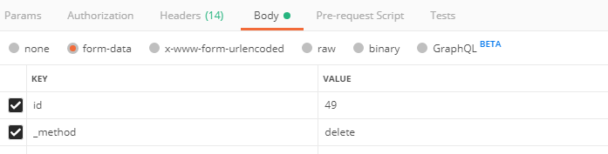*Parameters :*

*Response :*

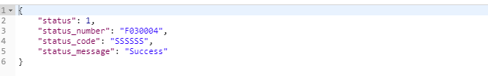

* + *Activate*

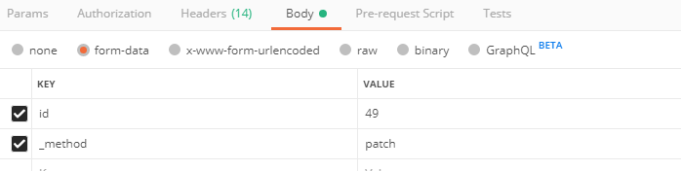*Parameters :*

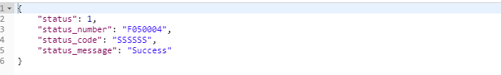*Response :*

* + *Deactivate*

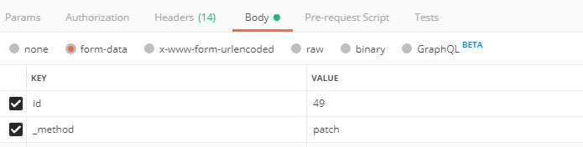*Parameters :*

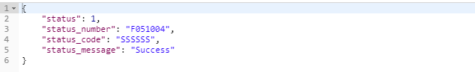*Response :*

1. *Advertisement Image*
   * *Get*

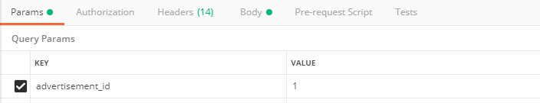*Parameters:*

*Response:*

{

"status": 1,

"status_number": "F000004",

"status_code": "SSSSSS",

"status_message": "Success",

"data": [

{

"id": 1,

"advertisement_id": 1,

"image_size_id": 10,

"link": "15c6bbedbcac5620190219153123.jpeg",

"isForce": 0,

"_min": 5,

"action": null,

"created_at": "2019-02-19 15:31:24",

"updated_at": "2019-02-19 15:31:24",

"deleted_at": null,

"advertisement": {

"id": 1,

"account_id": 1,

"group_id": 1,

"name": "CFC - Paket Puas Rp.29.000 2pcs Ayam + 1 Nasi",

"code": "WZSIDB1RQAHEMZ3",

"description": "<p>&nbsp;<\/p>",

"priority": 1,

"_start": "2019-02-19",

"_end": "2019-02-28",

"type": "01",

"gender": "00",

"_impression": 1500870,

"_click": 127,

"_view": 0,

"_action": 0,

"_lead": 0,

"_unlead": 0,

"budget": 0,

"price": 0,

"isDaily": 0,

"daily_target": null,

"daily_reach": 0,

"target": 1000000,

"hit": 10,

"reach": 10,

"isFeatured": 0,

"isSelected": 1,

"isSelectedPlace": 1,

"os": [],

"isActive": 1,

"status": "00",

"created_at": "2019-02-19 15:24:34",

"updated_at": "2019-07-17 06:50:18",

"deleted_at": null,

"placement_ids": [

1

],

"age_ranges": [],

"kotas": [],

"witels": [],

"regionals": [],

"type_text": "cpm",

"gender_text": "male",

"status_text": "process"

},

"image_size": {

"id": 10,

"name": "Banner Kotak Besar",

"alias": "REC_645_360",

"width": 645,

"height": 360,

"sort": 0,

"created_at": "2017-12-12 15:18:04",

"updated_at": "2017-12-12 15:18:04",

"deleted_at": null

}

}

]

}

* + *Add*

*Parameters:*

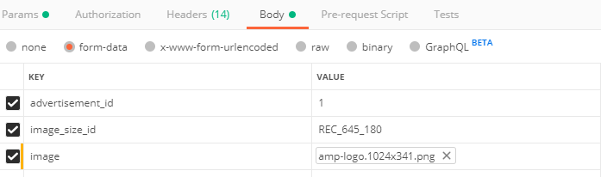

*Response:*

{

"status": 1,

"status_number": "F010007",

"status_code": "SSSSSS",

"status_message": "Success",

"data": {

"id": 56,

"advertisement_id": 1,

"image_size_id": 15,

"link": "15d39224ec81c020190725103022.png",

"isForce": 0,

"_min": 5,

"action": null,

"created_at": "2019-07-25 10:30:22",

"updated_at": "2019-07-25 10:30:22",

"deleted_at": null,

"advertisement": {

"id": 1,

"account_id": 1,

"group_id": 1,

"name": "CFC - Paket Puas Rp.29.000 2pcs Ayam + 1 Nasi",

"code": "WZSIDB1RQAHEMZ3",

"description": "<p>&nbsp;<\/p>",

"priority": 1,

"_start": "2019-02-19",

"_end": "2019-02-28",

"type": "01",

"gender": "00",

"_impression": 1500870,

"_click": 127,

"_view": 0,

"_action": 0,

"_lead": 0,

"_unlead": 0,

"budget": 0,

"price": 0,

"isDaily": 0,

"daily_target": null,

"daily_reach": 0,

"target": 1000000,

"hit": 10,

"reach": 10,

"isFeatured": 0,

"isSelected": 1,

"isSelectedPlace": 1,

"os": [],

"isActive": 1,

"status": "00",

"created_at": "2019-02-19 15:24:34",

"updated_at": "2019-07-17 06:50:18",

"deleted_at": null,

"placement_ids": [

1

],

"age_ranges": [],

"kotas": [],

"witels": [],

"regionals": [],

"type_text": "cpm",

"gender_text": "male",

"status_text": "process"

},

"image_size": {

"id": 15,

"name": "Rectangle 645:180",

"alias": "REC_645_180",

"width": 645,

"height": 180,

"sort": 0,

"created_at": "2019-03-15 10:11:33",

"updated_at": "2019-03-15 10:11:33",

"deleted_at": null

}

}

}

* + *Update*

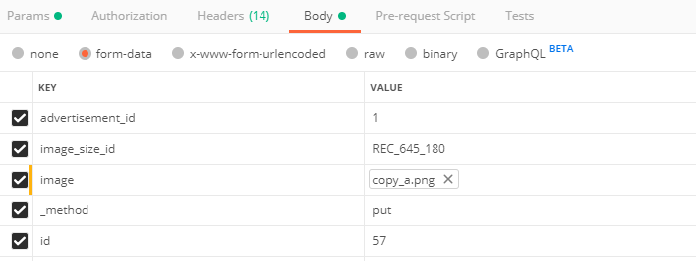*Parameters:*

*Response:*

{

"status": 1,

"status_number": "F020008",

"status_code": "SSSSSS",

"status_message": "Success",

"data": {

"id": 56,

"advertisement_id": 1,

"image_size_id": 10,

"link": "15d3922c2d261b20190725103218.png",

"isForce": 0,

"_min": 5,

"action": null,

"created_at": "2019-07-25 10:30:22",

"updated_at": "2019-07-25 10:32:18",

"deleted_at": null,

"advertisement": {

"id": 1,

"account_id": 1,

"group_id": 1,

"name": "CFC - Paket Puas Rp.29.000 2pcs Ayam + 1 Nasi",

"code": "WZSIDB1RQAHEMZ3",

"description": "<p>&nbsp;<\/p>",

"priority": 1,

"_start": "2019-02-19",

"_end": "2019-02-28",

"type": "01",

"gender": "00",

"_impression": 1500870,

"_click": 127,

"_view": 0,

"_action": 0,

"_lead": 0,

"_unlead": 0,

"budget": 0,

"price": 0,

"isDaily": 0,

"daily_target": null,

"daily_reach": 0,

"target": 1000000,

"hit": 10,

"reach": 10,

"isFeatured": 0,

"isSelected": 1,

"isSelectedPlace": 1,

"os": [],

"isActive": 1,

"status": "00",

"created_at": "2019-02-19 15:24:34",

"updated_at": "2019-07-17 06:50:18",

"deleted_at": null,

"placement_ids": [

1

],

"age_ranges": [],

"kotas": [],

"witels": [],

"regionals": [],

"type_text": "cpm",

"gender_text": "male",

"status_text": "process"

},

"image_size": {

"id": 10,

"name": "Banner Kotak Besar",

"alias": "REC_645_360",

"width": 645,

"height": 360,

"sort": 0,

"created_at": "2017-12-12 15:18:04",

"updated_at": "2017-12-12 15:18:04",

"deleted_at": null

}

}

}

* + *Delete*

*Parameters:*

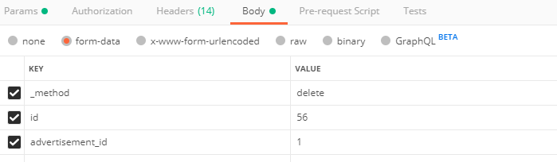

*Response:*

{

"status": 1,

"status_number": "F030005",

"status_code": "SSSSSS",

"status_message": "Success"

}

1. *TelkomAp*

*Get (*http://{server}/frog/openApi/telkomap/loc_id)

*Example : column loc_id*

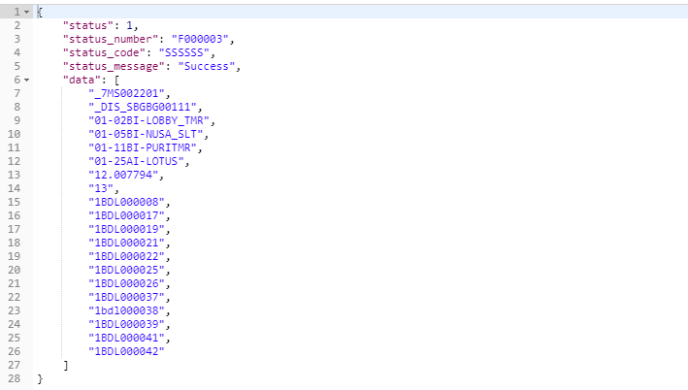*Response :*